**Best Paper Awards**

A 14 - D. Aarthi

Research Scholar, Sri Ramakrishna Mission Vidyalaya College of Arts and Science, Coimbatore, Affiliated to Bharathiar University.

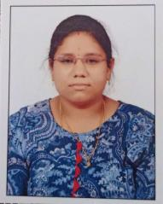

A301 - Priya Dadarao Dule

Gurunanak College of Pharmacy, Nagpur (Maharashtra)



A100 - Ms.Aswathi Sreenivasan C.V.

Avinashilingam Deemed University

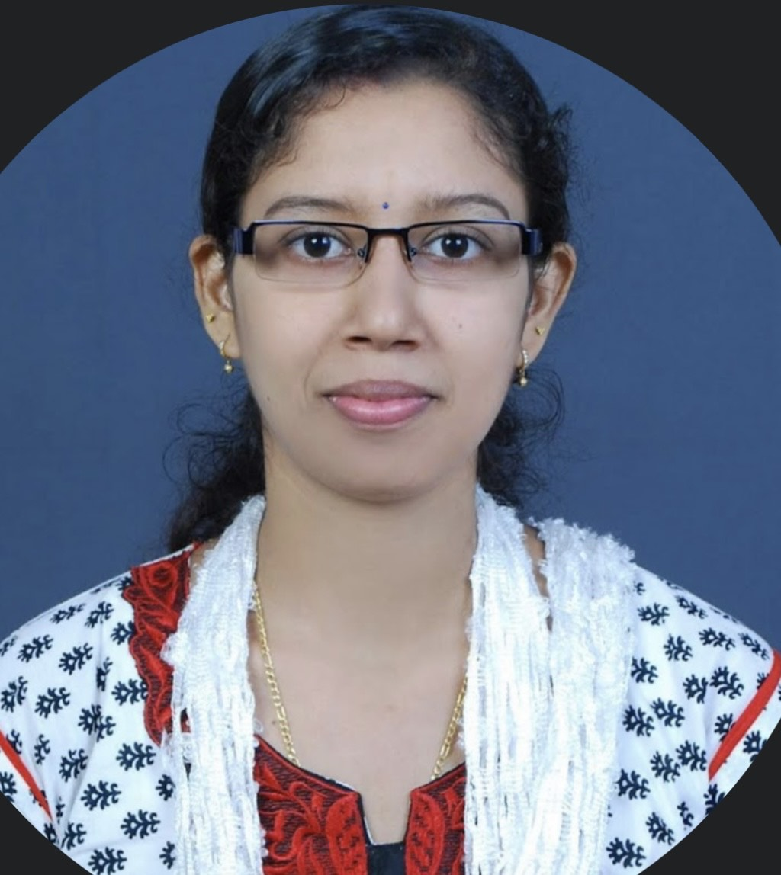

AO9 - **Dr. Jayanthi Rajendran**

Assistant Professor

Department of English

Madras Christian College

Chennai

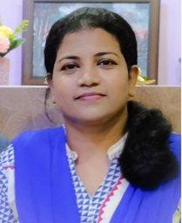

A223 - **Dr. SUDHEER S MARAR**

PROFESSOR & HOD, DEPARTMENT OF MCA

NEHRU COLLEGE OF ENGINEERING AND RESEARCH CENTRE, KERALA

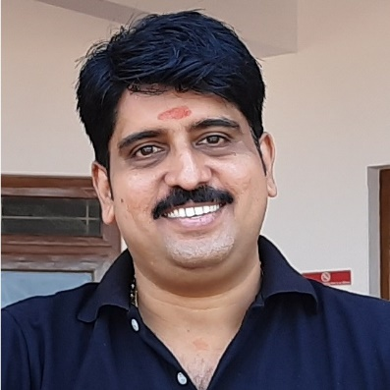

A180 - **Mr. C. NITHIYAPATHI**

Affiliation: Assistant Professor, Department of Mechanical Engineering, Karpagam Academy of Higher Education, Coimbator641021.

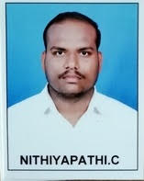0